# Amateur Radio Station EMR Safety Management Book

|  |  |
| --- | --- |
| **Amateur Callsign** |  |
| **Station Location** |  |
| **Assessed By** |  |
| **Assessment Date** |  |

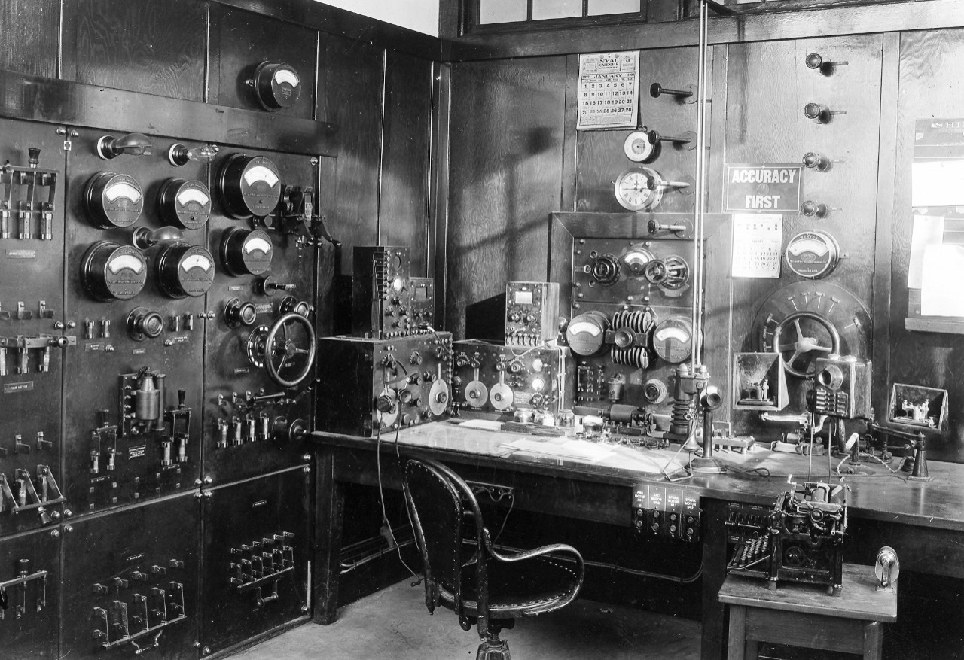

# Transmitting Antenna System Summary

|  |  |  |  |  |
| --- | --- | --- | --- | --- |
| Ant. System/Item | System 1 | System 2 | System 3 | System 4 |
| **Description** |  |  |  |  |
| **Location (public/private)** |  |  |  |  |
| **Frequency** |  |  |  |  |
| **Tx Power** |  |  |  |  |
| **Tx Modes** |  |  |  |  |
| **Tx Time (% of 6 mins)** |  |  |  |  |
| **Antenna Type/Gain** |  |  |  |  |
| **Antenna Height (lowest point)** |  |  |  |  |
| **Coax Type/Losses** |  |  |  |  |
| **Compliance Class** |  |  |  |  |

**EMR Safety Requirements:**

**System 1:**

**System 2:**

**System 3:**

**System 4:**

**Statement of Compliance:**

The table above outlines calculations I have done for the antennas I transmit on and to the best of my ability I comply with the EMF/EME requirements.

Signed: Date:

# System 1

# System 2

# System 3

# System 4

# Appendix I: Resources

* Amateur Radio EMR Flowchart: https://www.wia-education.com.au/resources-for-clubs
* RSGB Calculator: https://rsgb.services/public/software/emccalculator/